**Ex. No.: 11** Date: 26/04/2022

**Problem statement:**

Write a program to call a number.

1. Permission code in Android-Manifest.xml file.  
   You need to take permission from user for phone call.
2. Edit text to write phone number on which you want to make phone call and button for starting intent or making call.
3. In Main activity Intent object is created to redirect activity to call. Phone number input by user is parsed through Uri and that is passed as data in Intent object which is then used to call that phone number

**Design: (Block diagram)**

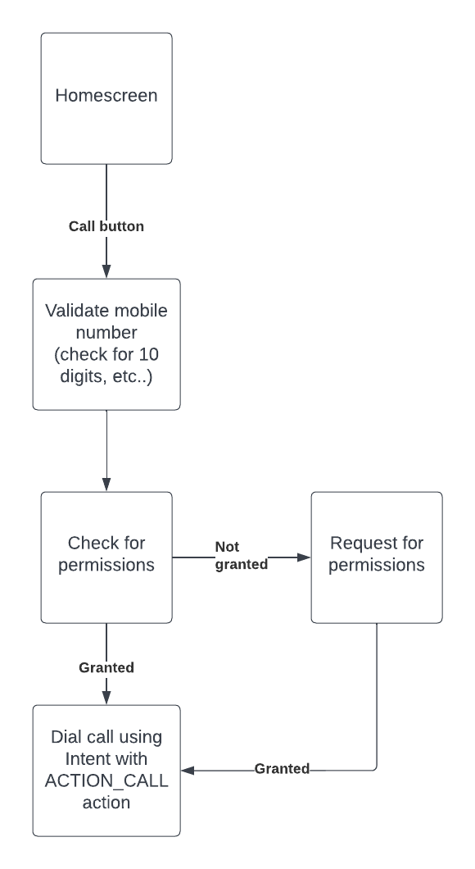

**Tool used:**

* Android Studio
* Java
* XML
* ACTION_CALL Intent

**Code:** <https://drive.google.com/drive/folders/1u8ElQB8XJZjceTi7eKKwce0liXQrwOrZ?usp=sharing>

**Screenshots of application:**

